Assignment 5: Xs and Os Game

Eoghan Monahan 17305786

Kaelan Quinn 17309983

# Game Specification and Usage Instructions

## Basic Goal

The game is the typical Xs and Os game as seen popularly. Two players, one represented by Xs and one by Os, take turns in marking a 3x3 grid in an attempt to get 3 of their symbols into a row, column, or diagonal.

*Figure 1: The Game Board*

## Symbol Representation

Due to instruction limitations, we were not able to go with the classic X and O shapes. Instead, 1 row of 4 lights is used to represent X, and 2 rows of 4 lights is used to represent O.

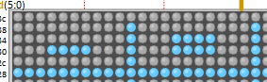

*Figure 2: “X” and “O” respectively*

## Input

All inputs are done using the inport row of switches at the top of the diagram. Toggling of different bits causes separate effects.

### Zone Selection

Selecting what area of the board you would like is done using the 8 least significant bits. Having these bits all unasserted will select the top left hand corner, having the least significant bit will select the top centre, etc.

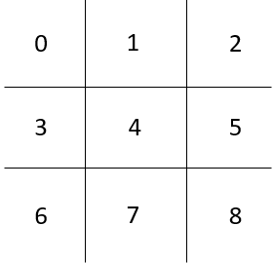

*Figure 3: Zone numbering*

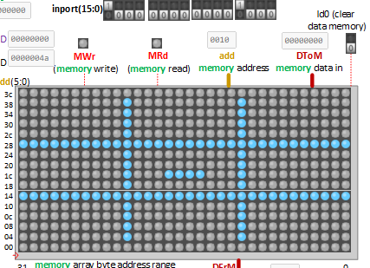

*Figure 4: Example showcasing input and location written to*

### Enabling Input and Switching between X and O

Enabling input is done using the most significant bit and switching between writing X and O is done using the 9th most significant bit. Input is enabled if the most significant bit is asserted. Deasserting this value allows for date entry without misinput. X is written when the 9th bit is deasserted, O if it is asserted.



*Figure 5: Showcasing bits used for enabling input and switching of X and O*

## Game Completion

If we have a winner, this screen is drawn. To restart the game, reset the device and clear the memory.

*Figure 6: Win Screen*

If the board is full and there is no winner, the game will instead come to a draw. The game is restarted in the same way as in the winner case.

*Figure 7: Draw Screen*